**STEPS TO BUILD SEVERLESS IOT DATA PROCESSING:**

**1. Create IBM Cloud Functions:**

- Head to the IBM Cloud console.

- Navigate to the Cloud Functions section.

- Set up a new action to process your IoT data.

**2. Integrate Smart Devices:**

- Identify your smart devices and their communication protocols

(MQTT, HTTP, etc.).

- Utilize IBM Watson IoT or other relevant services for device management.

- Configure devices to send data to your cloud.

**3. Set Up Data Collection:**

- Define the structure of your dataset.

- Establish a mechanism to collect and store data.

- IBM Cloud services like Cloud or Db2 could be useful.

**4. Implement Triggers:**

- Use Cloud Functions triggers to initiate processing when new data arrives.

- Ensure your function can handle the incoming data format.

**5. Data Processing in Cloud Functions:**

- Write functions to process incoming data.

- Leverage serverless capabilities for scalability and cost-effectiveness.

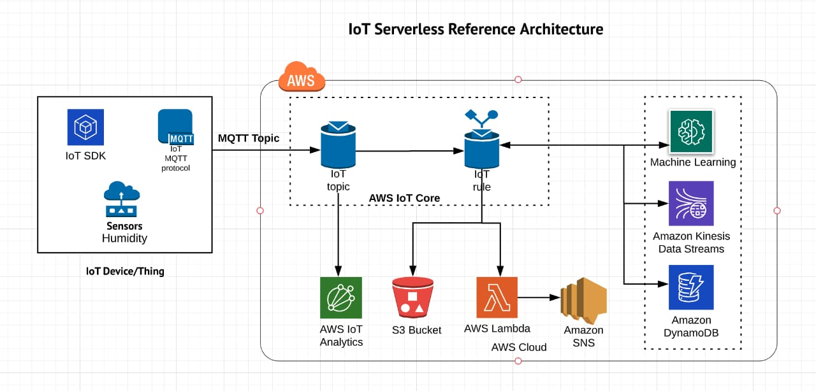

**SERVERLESS IOT DATA PROCESSING COMES WITH ITS SET OF CHALLENGES:**

**1. Cold Start Latency:**

- Functions may experience latency when starting up, impacting real-time processing.

**2. Limited Execution Time:**

- Functions typically have a time limit, which might be a constraint for complex or time-consuming processing tasks.

**3. Stateless Nature:**

- Serverless functions are stateless, making it challenging to maintain state across multiple invocations.

**4. Vendor Lock-In:**

- Depending heavily on a specific cloud provider's serverless platform can lead to vendor lock-in.

**5. Security Concerns:**

- Handling sensitive data requires robust security measures, especially in a serverless environment.

**6. Debugging Complexity:**

- Debugging serverless functions can be more challenging compared to traditional architectures.

**7. Scaling Issues:**

- Automatic scaling might not always match the exact needs of your IoT application, leading to overprovisioning or underprovisioning.

**8. Dependency Management:**

- Managing dependencies for your functions, especially if they include external libraries, can be tricky.

**9. Monitoring and Debugging:**

- Effective monitoring and debugging tools are crucial for identifying and resolving issues in a serverless environment.